Docker Tasks

1. Docker Installation
Install Docker on your local system (Windows, macOS, or Linux).
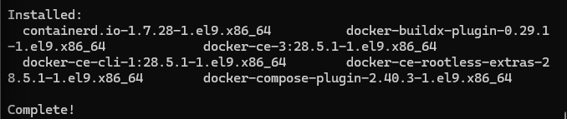
Verify installation by running:
docker --version
docker info
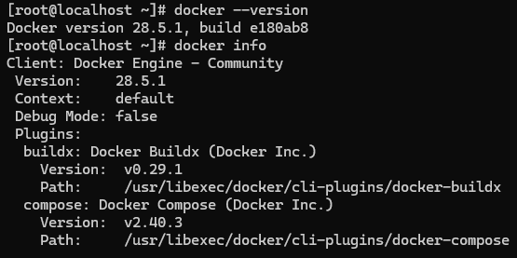

2. Working with Docker Images
Search for the official Ubuntu image on Docker Hub.
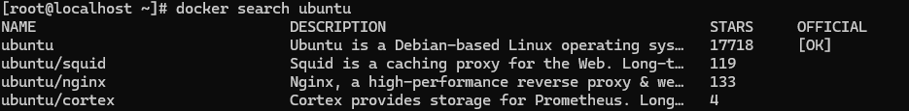
Pull it to your local system using docker pull.
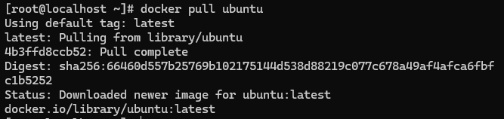

List all available images using:
docker images
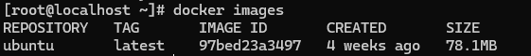

3. Creating a Docker Container
Run a container using the Ubuntu image.
Execute a command inside the container:
echo "Hello, Docker!"

4. Inspect Container (Created State)
Verify that the Ubuntu container is in the "created" state.
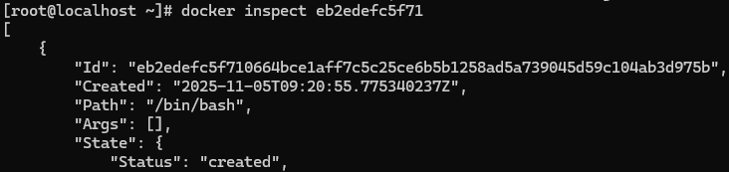
5. Run Container (Running State)
Execute the Ubuntu container and confirm it’s in the "running" state.
6. Launch and Remove HTTP Container
Launch an HTTP container.
Verify its state.

Remove both the container and its image from your system.
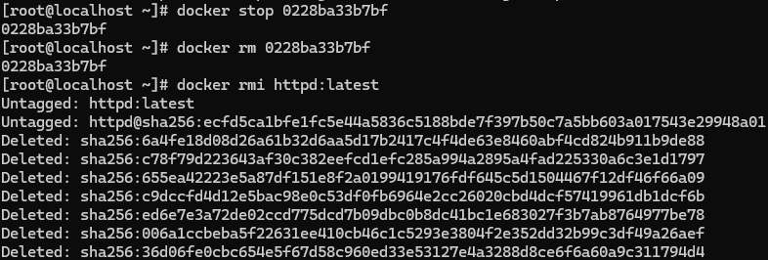

7. List Short Container IDs
Execute a command that displays only the short container IDs.
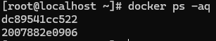

8. Clone & Build Custom Image
Clone the repository: lancachenet/ubuntu-nginx
Build a Docker image using the provided Dockerfile.
Add relevant tags while building the image.

9. Run & Test the Webpage
Run a Docker container using the newly built image.
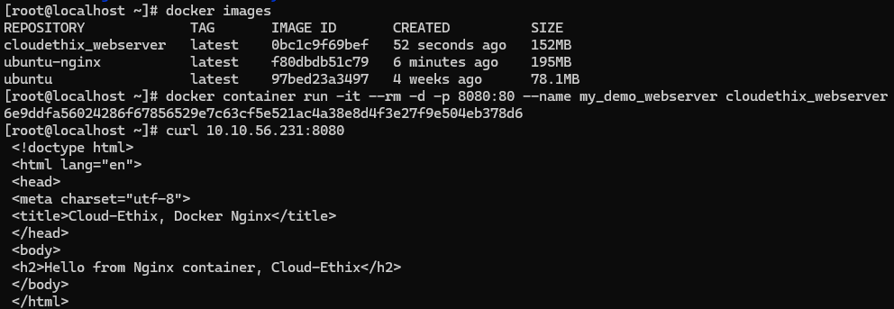

Use the curl command to verify that the webpage is accessible.

10. Container Detach & Reattach
Launch an Ubuntu container.
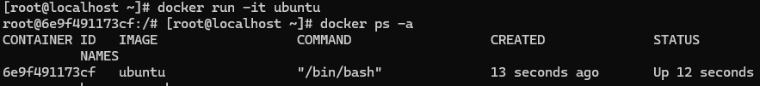
Demonstrate the escape sequence (detach).
While inside the container, press the escape sequence: Ctrl +p Ctrl +q
Reattach the container after detaching.
Check and note down the container’s IP address.
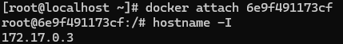

12. Inspect Host Configuration
Use a Docker command to inspect the hostname and the /etc/hosts file of the httpd container.
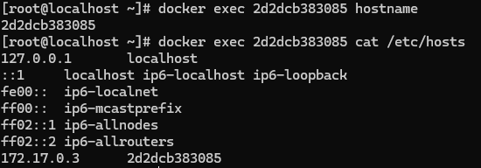
13. Monitor Container Stats
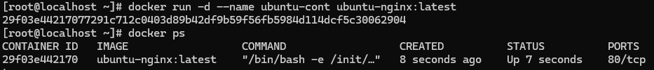

Inspect a container created with the lancachenet/ubuntu-nginx image.
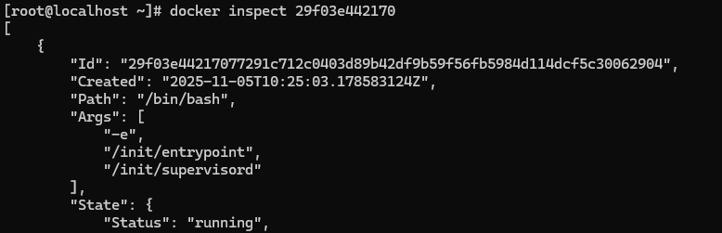
Monitor its resource usage and stats using the top command.
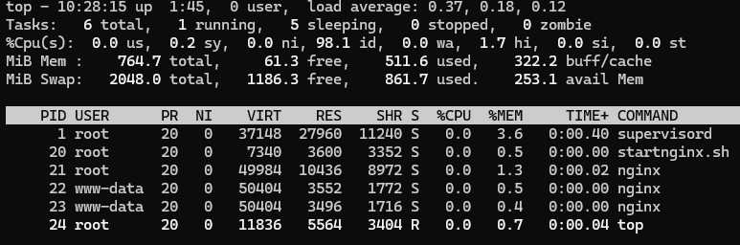

14. Nginx Containers Log Review
Start a new Nginx container.
Review and compare the logs for both Nginx containers.
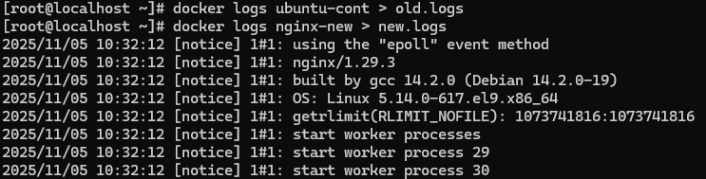
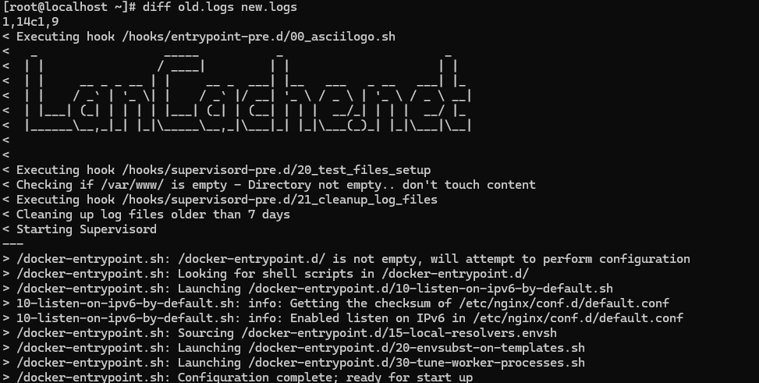
15. System Events & Filters
Examine Docker system events filtered by:
Specific date, and
The last 30 minutes.
Apply two filters simultaneously using name and event.

16. Custom Hostname & Logs
Create an Ubuntu container with: A meaningful name, and Hostname set to cloudethix.com.
Stop or kill the container.
Check its exit code and review its logs for details.
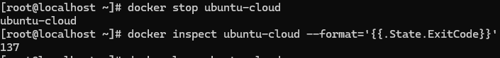

17. Container Management Operations
Create and start an Ubuntu container with a random name, then rename it to Ubuntu01.
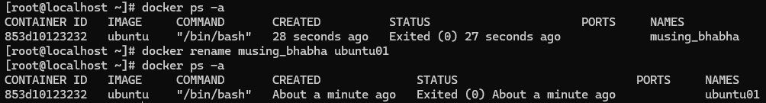
Launch another container named Ubuntu02.
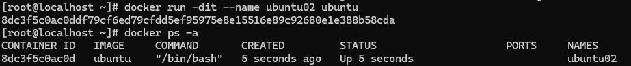
Check the hostname for both containers.
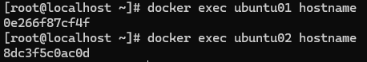
Perform the following:
Pause and unpause Ubuntu02.
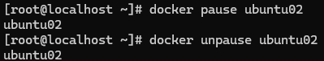
Stop, start, and restart Ubuntu01.
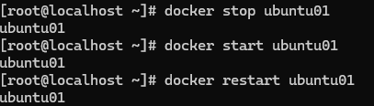
Inspect stats and system events for both.
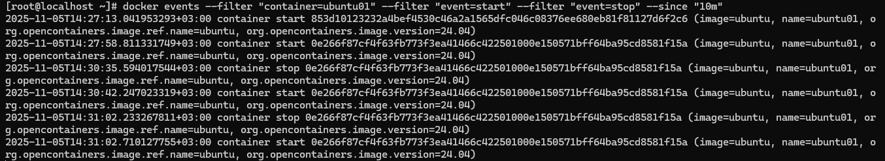
Finally, kill and delete the containers, ensuring all created directories are removed.
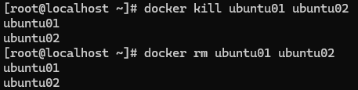

18. DockerHub Repository Setup
Create a DockerHub account.
Set up a repository with a meaningful name.
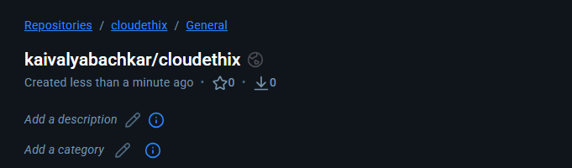
19. Run four HTTPD Docker containers with distinct, meaningful names, and apply restart policies (NO, On-Failure, Always, and Unless-Stopped) to each of the four containers, respectively. Demonstrate that the restart policies function as expected.
No_Policy:-
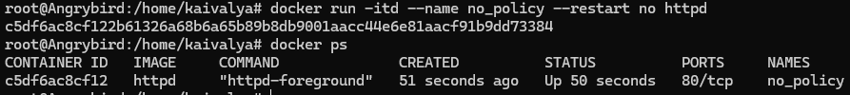
On-Failure:-
Restart-Always:-
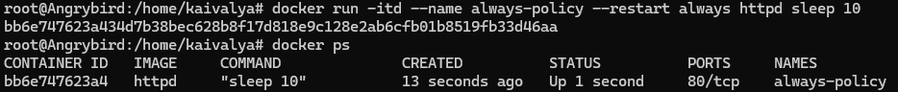
Unless-Stopped:-
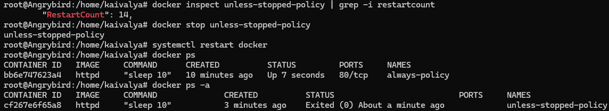

20. Change the restart policy of a above running container from the default to a custom policy using the docker update command.
e.g. docker update --help
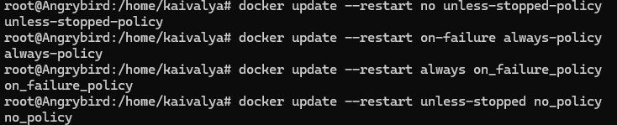
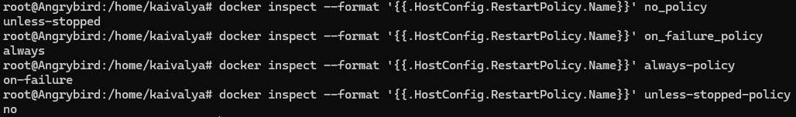
21. Launch an NGINX container with a meaningful name and expose it on the host's port 80. Create an "index.html" file containing the text "Hello there, Let's be the Team CloudEthiX," and copy the file to the container's "/usr/share/nginx/html/" location. Access the container in a browser to verify that the webpage displays correctly.
NGINX container with a cloudethix and expose it on the host's port 8080:-
Created a index.html file and copied the file cloudethix Container:-
Acces the container in a Browser to verify that the webpage displays correctly:-
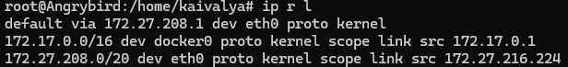
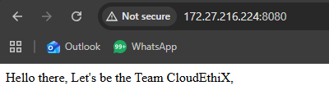

22. Run a docker container with CPU and Memory limit.
docker container run --help
ref links :-
https://phoenixnap.com/kb/docker-memory-and-cpu-limit
https://www.baeldung.com/ops/docker-memory-limit

Limiting CPU Usage:
Limiting Memory Usage:
Combining CPU and Memory Limits:

23. Update CUP and Memory of docker container using docker update.
ref links :-
https://docs.docker.com/engine/reference/commandline/update/
Update a container's cpu-shares (--cpu-shares):-
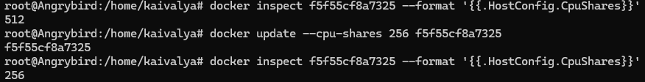
Update a container with cpu-shares and memory (-m, --memory):-

24. Pull the Busy-box image to your local system, tag it, and push it to the Docker Hub repository "yourname_cloudethix_busybox."
Pull the BusyBox image:-
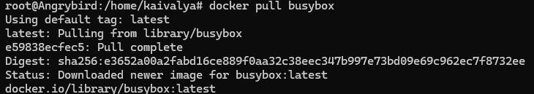
Tag the image:-

Log in to Docker Hub:-
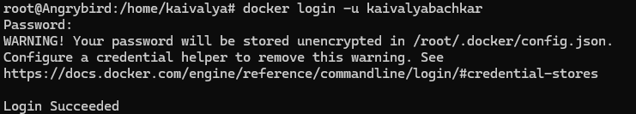
Push the tagged image to Docker Hub:-
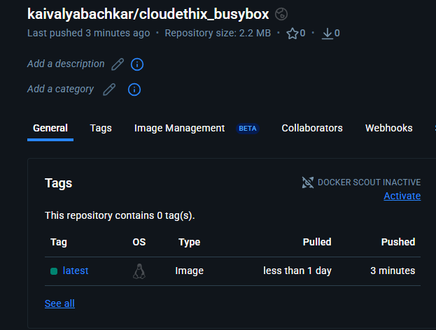
25. In your project directory, create a Dockerfile (named Dockerfile) with the following content.
FROM nginx:latest
COPY custom-index.html /usr/share/nginx/html/index.html
Ensure you also have a file named custom-index.html in the same directory. Build the Docker image using the Dockerfile you created and push it your repository. Delete the local image. Start a new container using the custom Nginx image that you just pushed. Map port 8080 on your host to port 80 in the container. Check the container page in browser.
Ensure files in the same directory:-
Build the Docker image using the Dockerfile:-
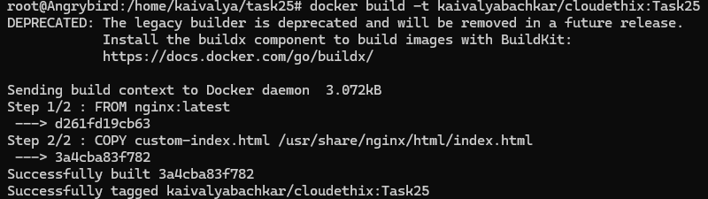

Push it your repository:-
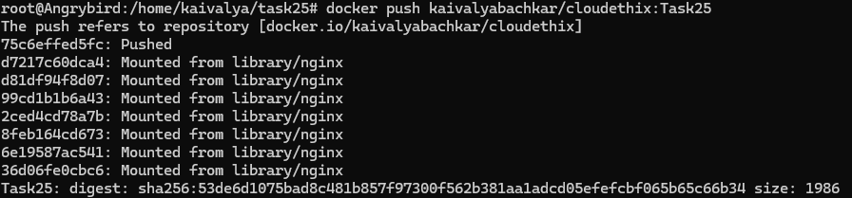
Delete the local image:-
Start a new container using the custom Nginx image was pushed and assigned Port 80:-
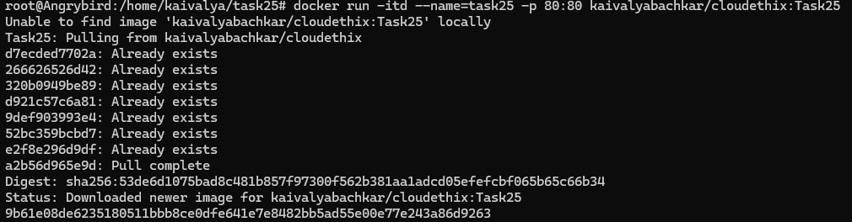
Check the container page in browser:-
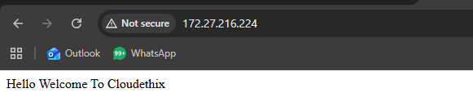
26. Push the Redis images tagged as version 1 and 3 to your Docker Hub repository, named "yourname_cloudethix_redis."
Pull the Redis image:-
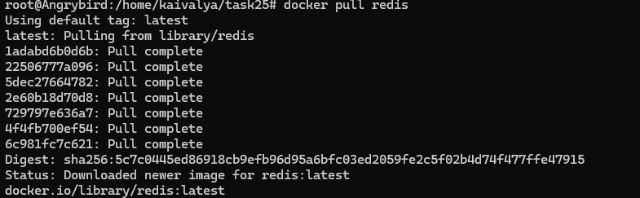

Tagged as version 1:-
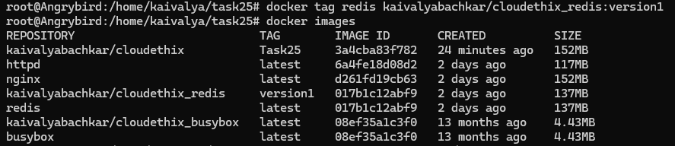
Pushed on Docker Hub repository:-
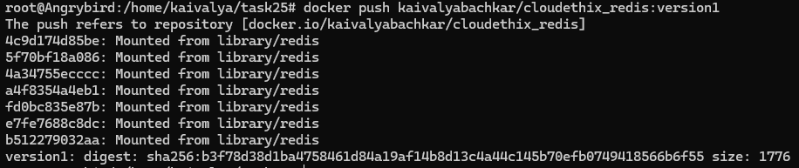
Tagged as version 3:-
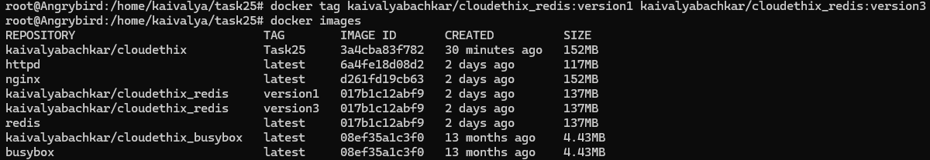
Pushed on Docker Hub repository:-
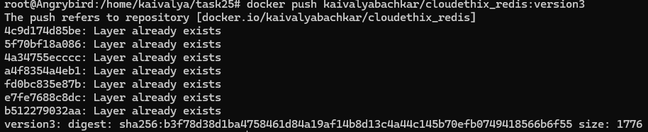
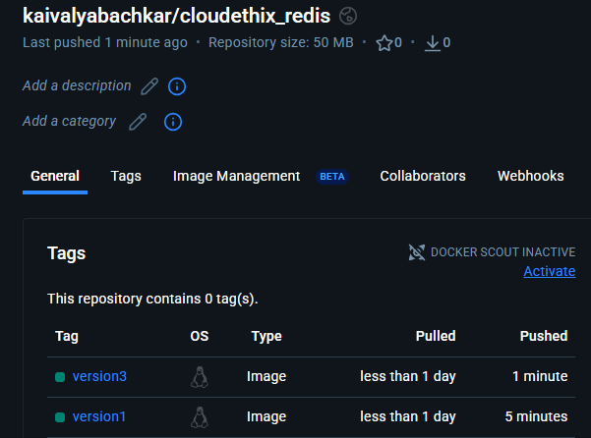

27. Create a remote Git repository and add the Dockerfile and index.html files. Clone the repository locally and create a release branch. Build the Docker image from the release branch with a meaningful tag, then run a container from the image and expose it on host port 8383. Check the webpage in a browser, and upon success, push the image to your Docker Hub repository named "yourname_cloudethix_nginx." Finally, push the release branch to the remote Git repository and merge it by creating a pull request.
Create a remote Git repository and add the Dockerfile and index.html files:-
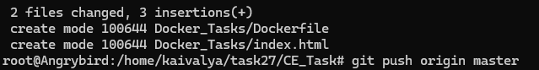
Clone the repository locally:-
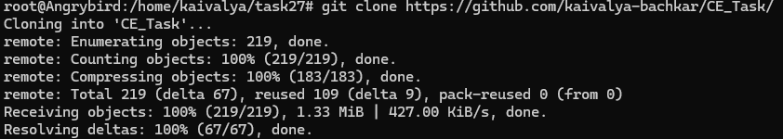
Create a release branch:-
Build the Docker image from the release branch with a tag:-
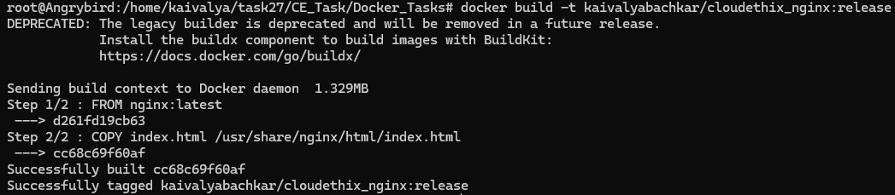
Run a container from the image and expose it on host port 8383:-
Check the webpage in a browser:-
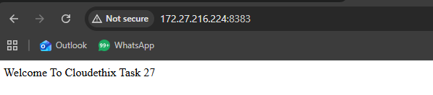

Push the image to your Docker Hub repository named "kaivalyabachkar/cloudethix_nginx:-
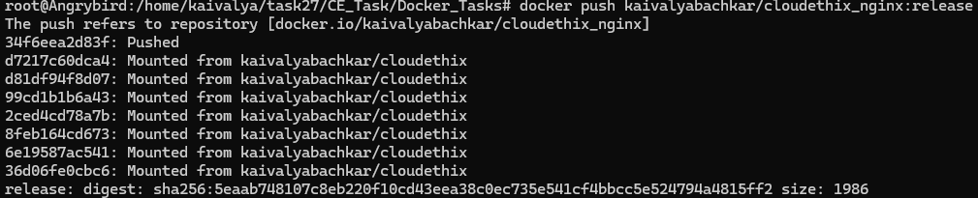
Push the release branch to the remote Git repository:-
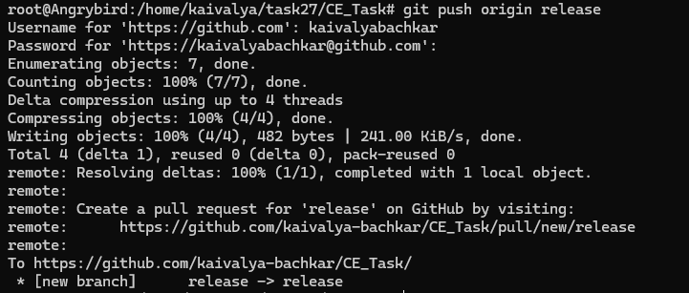
Merge it by creating a pull request:-
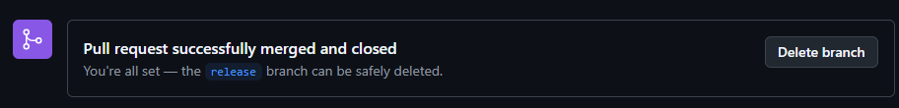
28. Save all local Redis images as a .tar file in the master branch of your local repository. Delete all Redis images from your local system and push the master branch to the remote repository. Load the Redis images from the tar file to your local system, and verify that all images have been loaded correctly.
Save all local Redis images as a .tar file in the master branch of your local repository:-
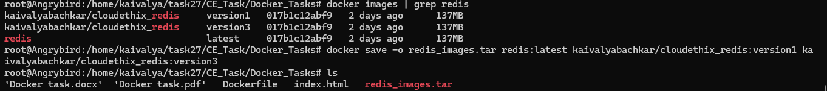
Delete all Redis images from your local system:-
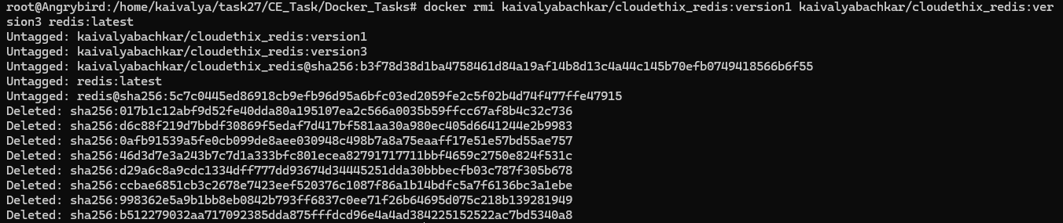

Push the master branch to the remote repository:-
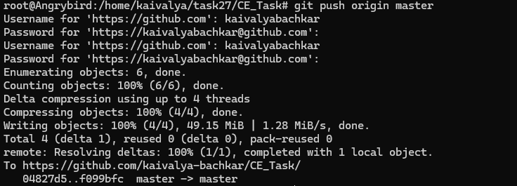
Load the Redis images from the tar file to your local system:-
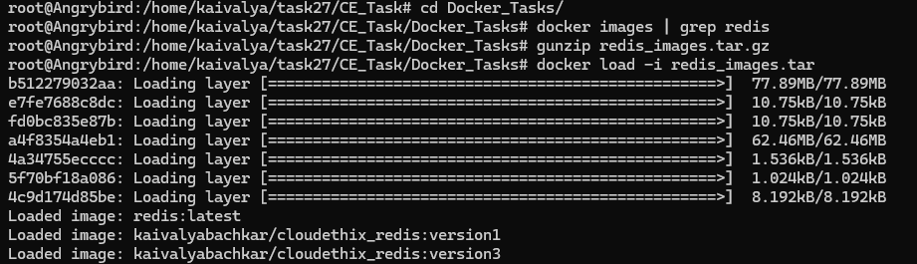
Verify that all images have been loaded correctly:-
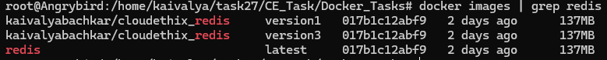

29. Pull the Busy-box image to your local system, tag it, and push it to the Docker Hub repository "yourname_cloudethix_busybox." Export the Docker image from the NGINX container, create a .tar file, and import the tar file to create a Docker image with a meaningful name. After importing the image, tag it and push it to the "yourname_cloudethix_busybox" Docker Hub repository.
Pull the Busy-box image to your local system:-
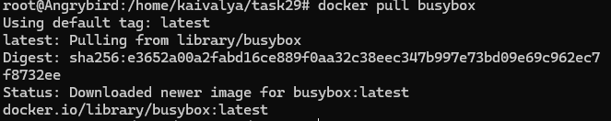
Tag it, and push it to the Docker Hub repository "yourname_cloudethix_busybox:-

Export the Docker image from the NGINX container Create a .tar file:-
Import the tar file to create a Docker image with a meaningful name:-
After importing the image, tag it and push it to the "yourname_cloudethix_busybox" Docker Hub repository:-
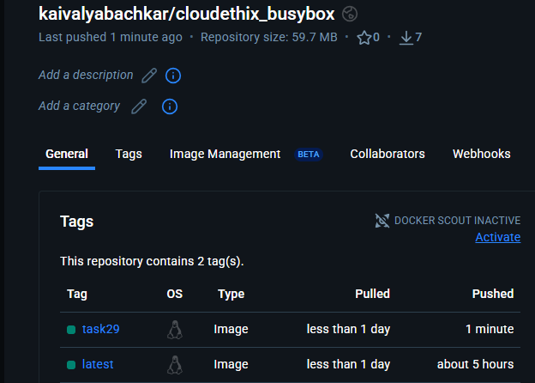

30. Dockerfile creation: Create a simple Dockerfile to build a custom image with the following specifications:
Base image: Ubuntu
Install packages: curl, vim, and git
Set an environment variable: MY_NAME=Your_Name
Build the custom image using docker build and list all available images using docker images.
Dockerfile creation :-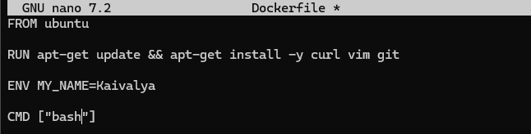

Build the custom image using docker build:-
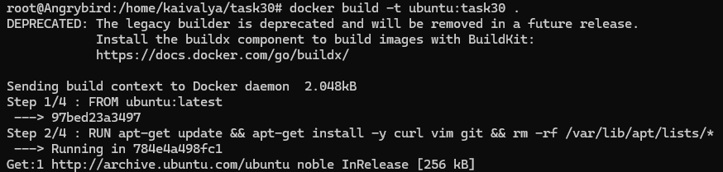
list all available images using docker images:-
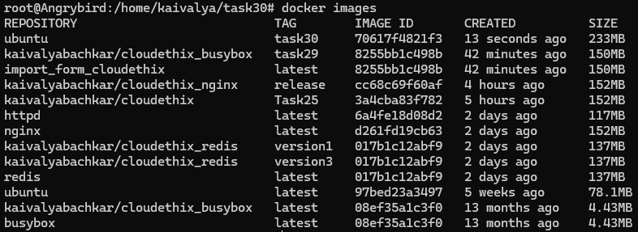
31. Create Directories: Establish two directories named "DHUB" and "AWSECR."
32. Dockerfile Creation: Develop two Dockerfiles to construct custom images with the following specifications:
- Base image: Ubuntu
- Install packages: httpd
- Add "I am from Docker Hub" to the index.html file for DHUB directory and "I am from ECR" for AWSECR directory.
- Set environment variable ENV_NAME=DHUB for the DHUB directory and ENV_NAME=AWSECR for the AWSECR directory.
- Start http service using ENTRYPOINT
- Expose port 80.
DockerFile For Docker Hub:-
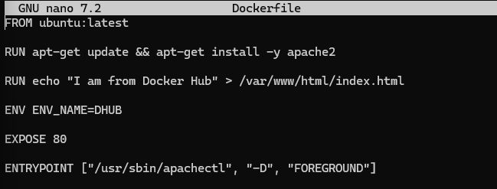
DockerFile For AWSECR:-
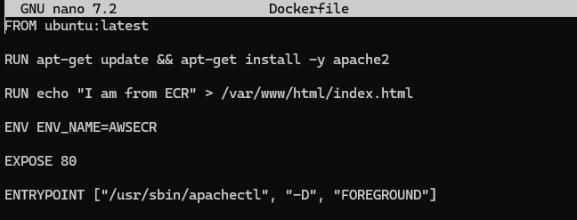

33. Build Custom Images: Utilize the docker build command to build the custom images. List all available images using docker images.
Image for Docker Hub:-
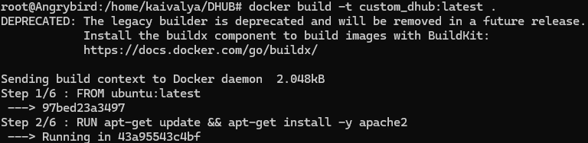
Image For AWSECR:-
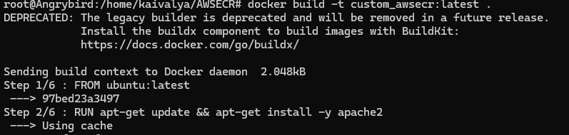

List all available images using docker images:-
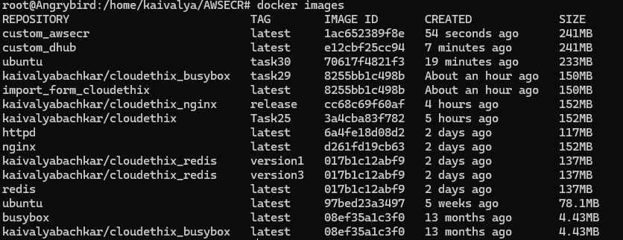
34. Push Images to Repositories: Push the Docker image to Docker Hub. Push the Docker image to AWS ECR.
Push the Docker image to Docker Hub:-
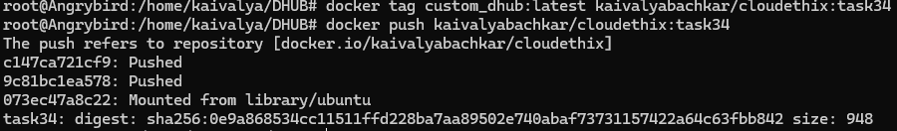
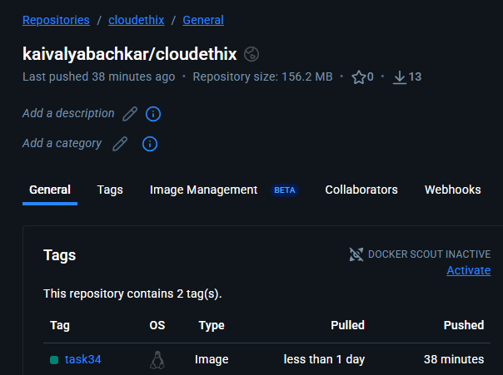

Push the Docker image to AWS ECR:-
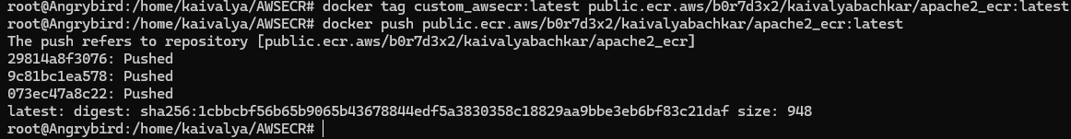
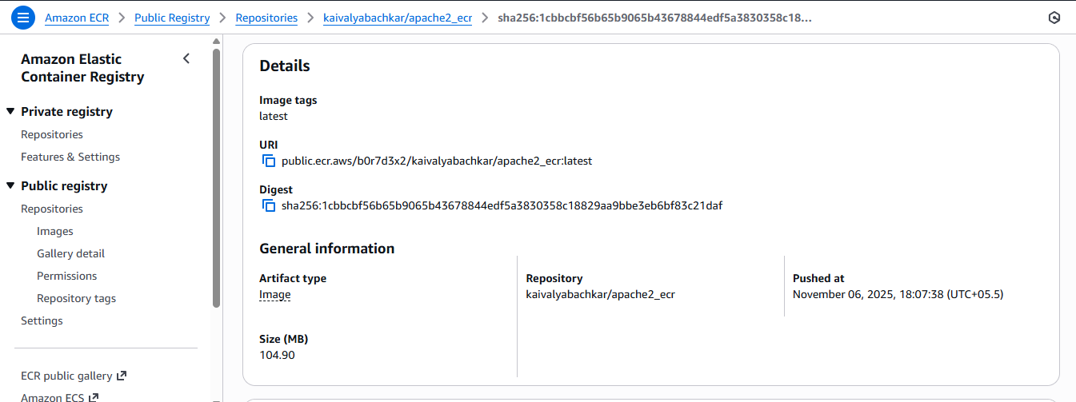

35. Run Containers:
docker run -d -p 8081:80 --name I_AM_FROM_DHUB your_docker_hub_image
docker run -d -p 8082:80 --name I_AM_FROM_ECR your_aws_ecr_image
36. Access Pages from Browser:
Open a web browser and access the pages:
For Docker Hub: http://localhost:8081
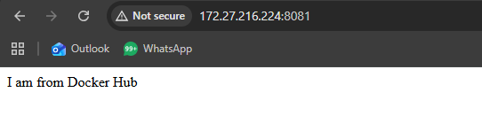
For AWS ECR: http://localhost:8082
